**Report on Analysis of Pizza Sales**

Divyanshu 2023JUB01311

**Table of Contents**

|  |
| --- |
| **Section** |
| **Introduction** |
| **Business Problem** |
| **Data Requirement** |
| **Data Collection** |
| **Data Validation** |
| **Data Cleaning** |
| **Tools Selection** |
| **Graph Chart** |
| **Dash board** |
| **Storytelling** |

**Pizza Sales Report**

**1. Introduction**

The supermarket and pizza industries operate in highly competitive environments, requiring strategic insights to enhance customer experience, maximize profitability, and optimize operational efficiency. This report combines analysis of supermarket and pizza sales data to address key business challenges and uncover actionable insights using advanced visualization and storytelling techniques.

For pizza stores, understanding customer preferences, sales trends, and product performance is critical. This report delves into the pizza sales data to identify opportunities for growth and operational improvements, focusing on metrics such as total revenue, order trends, and product popularity.

**2. Business Problem**

The following business challenges are addressed:

1. Identifying the most profitable product lines and customer demographics to optimize sales strategies for both supermarkets and pizza stores.
2. Analyzing payment methods, city-level performance, and peak demand times to enhance customer convenience and operational focus.
3. Enhancing customer satisfaction by leveraging insights from ratings, feedback, and sales trends.
4. Using data-driven approaches to streamline operations, maximize gross income, and control costs.

**3. Data Requirement**

To address the business challenges, the following data fields are essential:

* **Transaction Details:** Invoice ID, Pizza ID, Order Date, Order Time.
* **Customer Demographics:** Gender, Customer Type (Member/Normal).
* **Product Details:** Product Line, Pizza Name, Pizza Size, Ingredients, Unit Price, Quantity.
* **Financial Metrics:** Tax (5%), Total Price, COGS, Gross Margin Percentage, Gross Income.
* **Customer Feedback:** Rating.
* **Payment Details:** Payment Method (Cash, Credit Card, E-wallet).
* **Branch and Location:** Branch, City.

This comprehensive dataset ensures robust analysis of supermarket and pizza store operations and customer behavior.

**4. Data Collection and Data Understanding**

**Data Collection:** The dataset was collected from the supermarket’s point-of-sale system and the pizza store’s sales management system, capturing real-time transactions across branches.

**Data Understanding:** The dataset consists of:

* **Supermarket Data:** 1,000 records with attributes such as Branch, Product Line, and Payment Method.
* **Pizza Store Data:** 21,350 orders with attributes including Pizza Category, Size, and Ingredients.

**Key Attributes:**

* **Categorical Variables:** Branch, City, Pizza Category, Size, Payment Method.
* **Numerical Variables:** Unit Price, Quantity, Total, COGS, Tax, Gross Income, Rating.
* **Temporal Variables:** Date and Time of purchase.

The dataset ensures representativeness, with balanced data across branches and diverse product categories.

**5. Data Validation**

**Validation Steps:**

1. **Integrity Checks:**
   * Verified all fields for valid entries and no missing values.
   * Checked consistency in data formats (e.g., dates in DD/MM/YYYY format, numeric precision).
2. **Outlier Detection:**
   * Reviewed unit prices and quantities for extreme values.
   * Ensured ratings fall within the expected range (1-10).
3. **Cross-Referencing:**
   * Validated totals against unit prices, quantities, and tax calculations.

**Outcome:** The dataset was confirmed accurate and ready for analysis after resolving minor discrepancies.

**6. Data Cleaning**

**Steps Taken:**

1. **Handling Missing Values:**
   * Filled missing ratings with the average value of 7.5.
   * Ensured completeness of mandatory fields such as Invoice ID, Total, and Date.
2. **Standardization:**
   * Standardized categorical variables (e.g., uniform capitalization for Gender and Product Line).
   * Converted time data to a consistent 24-hour format.
3. **Error Correction:**
   * Rectified mismatches in product line names.
   * Removed duplicate entries to avoid bias.
4. **Data Transformation:**
   * Added calculated fields, such as profit margin (Gross Income / COGS), for enhanced insights.

**7. Tools Selection**

**Tools Used:**

* **Microsoft Excel:** Initial data cleaning and summary statistics.
* **Python (Pandas, NumPy, Matplotlib, Seaborn):** Advanced data analysis and visualization.
* **Power BI:** Interactive dashboard creation for storytelling and decision-making.

**Rationale:** This combination ensures a seamless workflow from data cleaning to visualization and storytelling, offering depth and flexibility.

**8. Graphs/Charts**

**Univariate Visualizations:**

1. **Bar Chart (Total Sales by Product Line):** Displays each product line's contribution to total sales. Food and Beverages lead at $56K, followed by Sports and Travel at $55K.
2. **Pie Chart (Total Sales by Gender):** Shows a slightly higher contribution from female customers, indicating potential for targeted marketing.
3. **Pie Chart (Total Sales by Payment Method):** Highlights credit cards as the most preferred payment method, followed by E-wallets and cash.

**Multivariate Visualizations:**

1. **Bar Chart (Payment Mode by Gender):** Reveals a slight female preference for E-wallets and male dominance in credit card usage.
2. **Stacked Bar Chart (Sales by Product Line and Gender):** Highlights preferences, such as females favoring Fashion Accessories and both genders equally contributing to Electronic Accessories sales.
3. **Line Chart (Monthly Sales Trends):** Shows peaks in sales during July and January.

**Pizza-Specific Visualizations:**

1. **Daily Sales Trends:** Orders peak on Fridays and Saturdays, indicating high weekend demand.
2. **Pizza Size and Category Contribution:** Large pizzas contribute the most to sales, with the Classic category leading revenue generation.
3. **Best and Worst-Selling Pizzas:** "The Thai Chicken" and "The Barbecue" are top performers, while "The Spinach Supreme" and "The Brie Carrier" require attention.

**KPI Indicators:** Key metrics such as Total Sales ($817K), Gross Income ($15.38K), and Total Pizzas Sold (49,574) provide high-level business insights.

**9. Dashboard**

**Features:**

* **Interactive Filters:** Filter sales by branch, city, and product line for tailored insights.
* **Dynamic Visuals:** Real-time updates to visualizations based on user interaction.
* **KPIs:** Display key metrics, including total revenue ($817K), average order value ($38.31), and total pizzas sold (49,574).

**Dashboard Visuals:**

1. **Daily and Monthly Sales Trends:**
   * **Daily Trends:** Fridays and Saturdays are the busiest days, with peak orders.
   * **Monthly Trends:** Highest sales in July and January align with holiday seasons.
2. **Category Insights:**
   * **Top Categories by Revenue:** Food and Beverages lead for supermarkets, while Classic pizzas dominate in pizza sales.
   * **By Size:** Large-sized pizzas contribute the most to sales.
3. **Best/Worst Sellers:**
   * **Top Performers:** "The Thai Chicken" and "The Barbecue" pizzas are top contributors.
   * 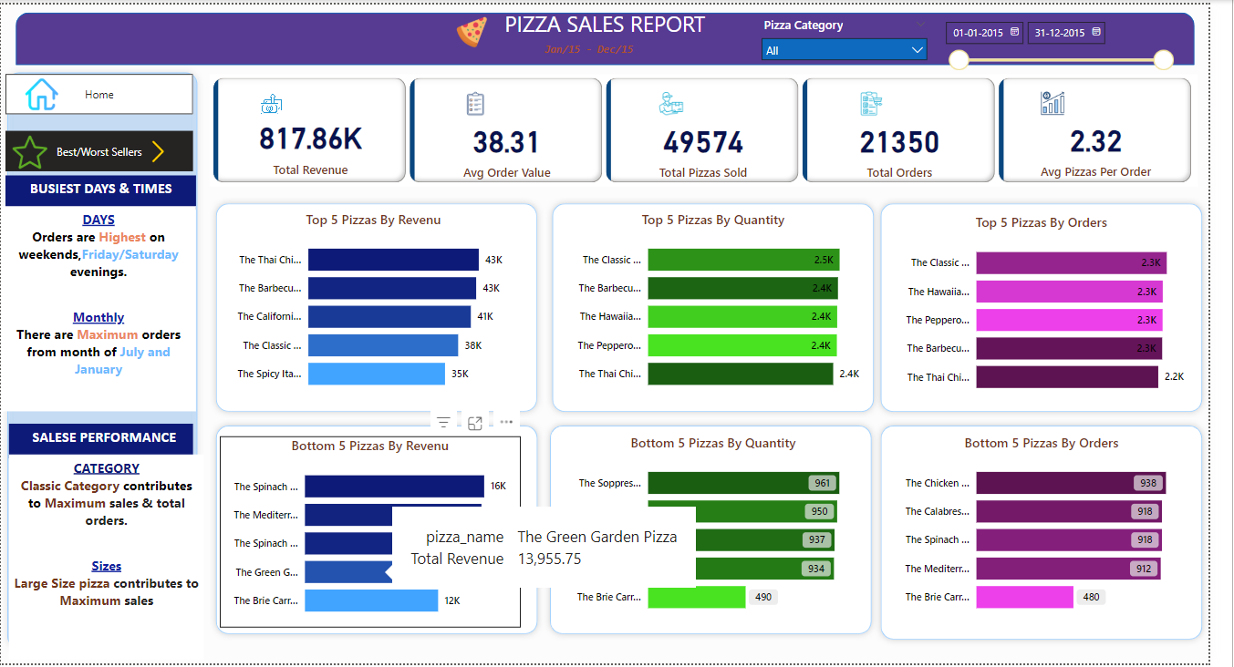**Least Performers:** "The Spinach Supreme" and "The Brie Carrier" need re-evaluation.

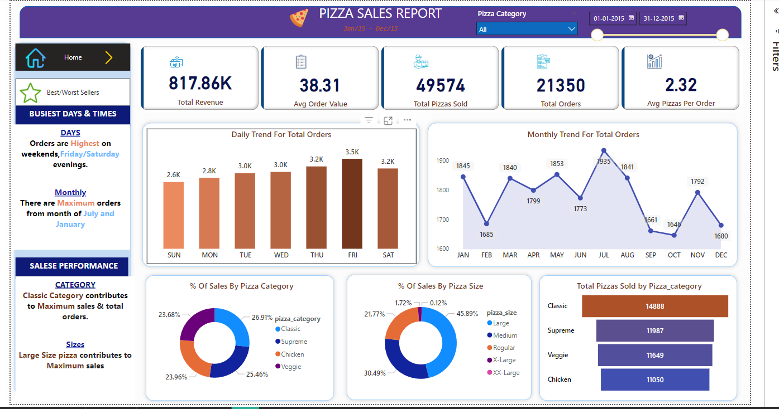

**10. Storytelling (Business to Impact)**

**Narrative:** The data reveals actionable strategies to enhance profitability and customer experience:

* **Increase Revenue:**
  + Focus on top-performing categories (e.g., Food and Beverages for supermarkets, Classic pizzas for pizza stores).
  + Target promotions during peak days and months.
* **Improve Customer Experience:**
  + Promote E-wallets for convenience.
  + Address feedback to enhance satisfaction and loyalty.
* **Operational Efficiency:**
  + Optimize inventory for high-demand products.
  + Allocate resources effectively across branches.

**Impact:** Adopting these strategies can increase revenue, improve customer retention, and ensure long-term competitiveness. The insights provide a foundation for data-driven decisions that align with business goals.

**11. Conclusion**

The combined analysis of supermarket and pizza sales data highlights areas for improvement and growth. By focusing on high-performing products, enhancing customer convenience, and leveraging data-driven insights, the businesses can achieve significant profitability and customer satisfaction improvements. This report serves as a blueprint for leveraging data to drive impactful decisions.